**HIGH LEVEL LANGUAGE EXTENSION WITH CURSORS**

**Program 1**

Write a Cursor program using MySQL to retrieve the email-ids(build an email list) of employees from employees table.

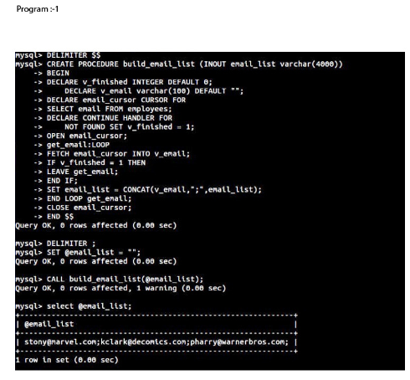

**RESULT:**

stony@marvel.com;kclark@dccomics.com;pharry@warnerbros.com;